**Analysing Google Apps Store Wireframe Author: Seerat Fatema**

**Analysing Google Apps Store**

(Wireframe)

Author: SEERAT FATEMA

**Analysing Google Apps Store Wireframe Author: Seerat Fatema**

**Contents**

1.Home page………………....................................................................................03

2.Installation Analysis..................................................................................05

3.Review Analysis ..........................................................................................06

3.Rating Analysis............................................................................................08

4.Other Analysis............................................................................................10

**Analysing Google Apps Store Wireframe Author: Seerat Fatema**

**Home Page**

Title: A prominent title reflects the purpose of your dashboard, such as "Analyzing Google App Store."

Theme: Consider incorporating a theme that align with the entertainment industry.

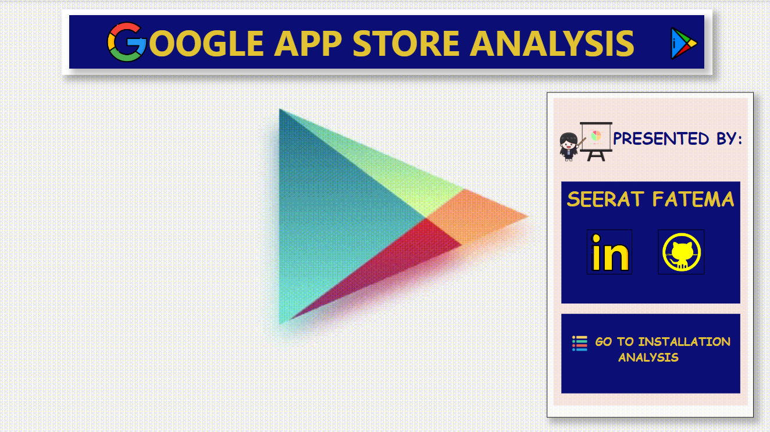

As per the requirement of the project, I have divided the analysis into five sections

* Installation Analysis
* Review Analysis
* Rating Analysis
* Other Analysis

Homepage will have the button to navigate to

* Installation Analysis Page

Homepage also have the two more buttons to navigate to:

* My LinkedIn Profile
* My GitHub Account

**Analysing Google Apps Store Wireframe Author: Seerat Fatema**

**Installation Analysis**

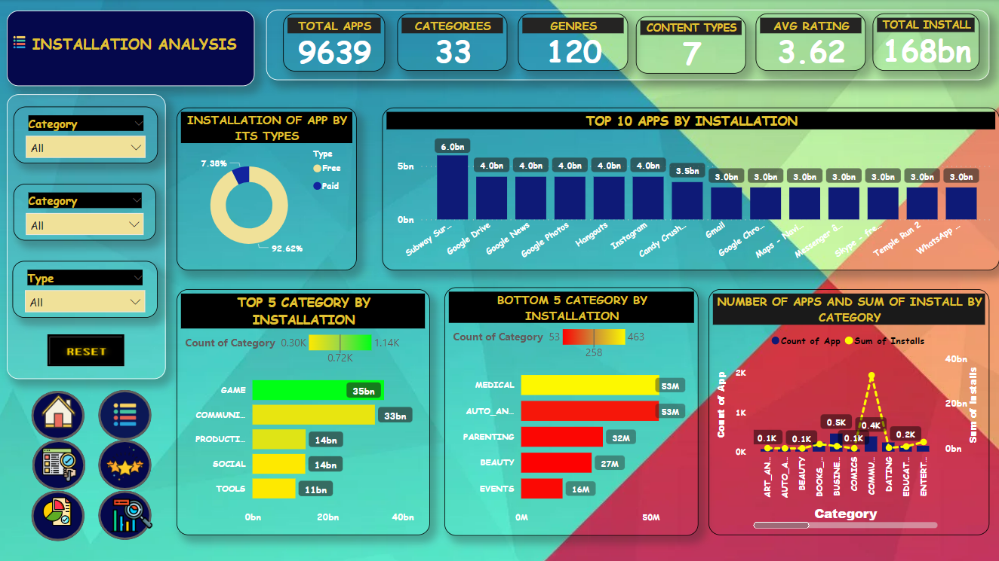

This page mainly focuses on the induvial entertainer, KPI list as follows

* Total Number of Apps
* Total Categories
* Total Genres
* Content Types
* Average Rating
* Total Install
* Top 5 Category By Installations
* Bottom 5 Category By Installations
* Number of Apps and sum of Installs By Category
* Percentage of App installations by its
* **Bar Graphs for Apps Installation** : Create bar graphs to visually represent the installations of apps. Display Apps on the x-axis and the corresponding number of installations on the y-axis.
* **Slicers for Filtering**: Add slicers to allow users to filter the data. Include slicers based on relevant criteria, such as Category, Genres, Type . Users can interact with the slicers to dynamically update the graph based on their selections.

**Analysing Google Apps Store Wireframe Author: Seerat Fatema**

* **Navigation Buttons**: Add six buttons at the bottom left side of the home page out of which five are for easy navigation to other sections of the dashboard and one is for data analyzation of installation page.

Label the buttons and by clicking on each button will redirect users to the respective pages.

**INSTALLATIONS OF APP BUY ITS TYPES**

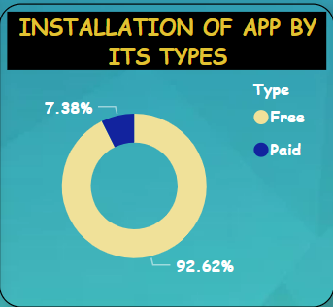

**TOP 10 APPS BY INSTALLATION**

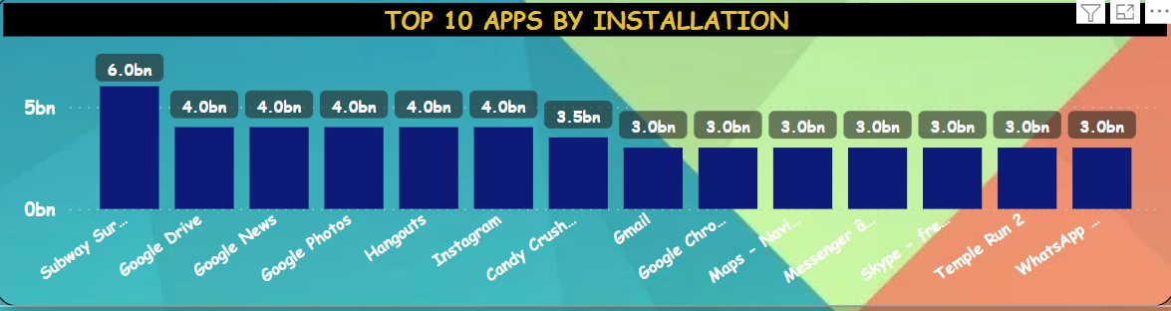

Subway surfer has the highest installations

**Analysing Google Apps Store Wireframe Author: Seerat Fatema**

**TOP 5 CATEGORY BY INSTALLATION**

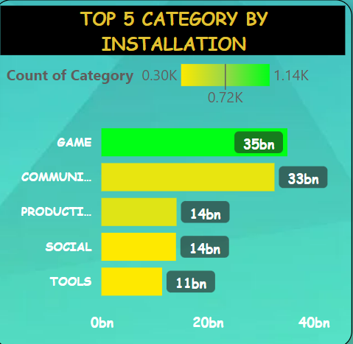

Game has the highest installation by category

**TOP 5 CATEGORY BY INSTALLATION**

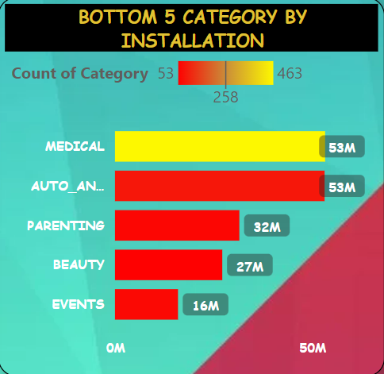

Events has the lowest installation by category

**Analysing Google Apps Store Wireframe Author: Seerat Fatema**

**NUMBER OF APPS AND SUM F INSTALLS BY CATEGORY**

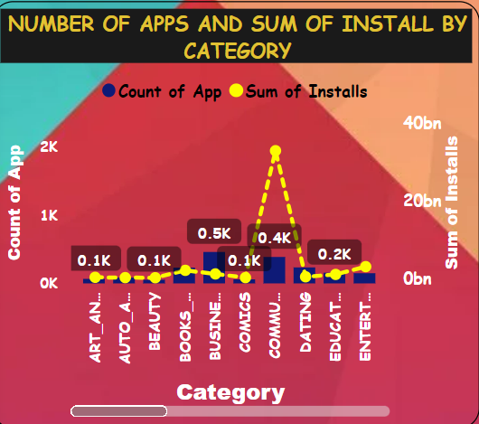

**Analysing Google Apps Store Wireframe Author: Seerat Fatema**

**Review Analysis**

* **Slicers for Filtering**: Add slicers to allow users to filter the data. Include slicers based on relevant criteria, such as Category, Genres, Type . Users can interact with the slicers to dynamically update the graph based on their selections.
* **Scroller**: Represents Top 10 Reviewed Apps
* **Pie Chart**: For representing the types of app by reviews.
* **Bar Graph**: Represents sum of reviews by category.
* **Area Chart:** Represents Reviews vs Rating by Genres.
* **Navigation Buttons**: Add six buttons at the bottom left side of the home page out of which five are for easy navigation to other sections of the dashboard and one is for data analyzation of installation page.

Label the buttons and by clicking on each button will redirect users to the respective pages.

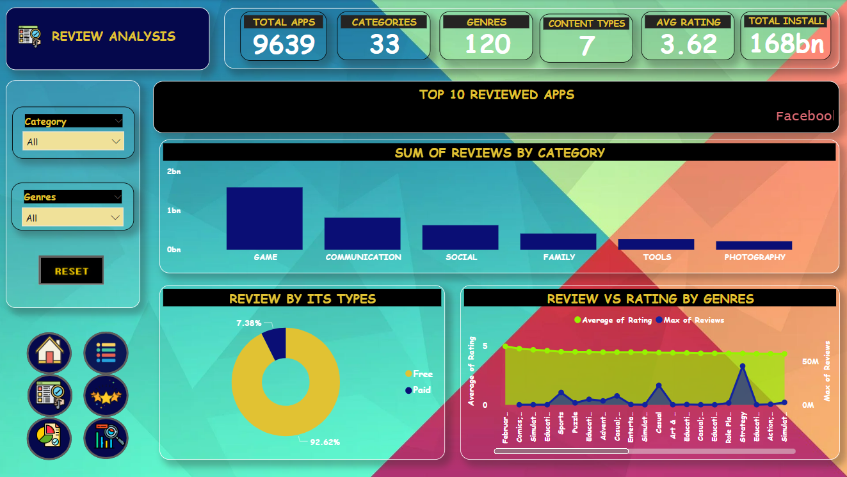

**Analysing Google Apps Store Wireframe Author: Seerat Fatema**

**TOP 10 REVIEWED APPS**



Facebook is most reviewed app.

SUM OF REVIEWS BY CATEGORY

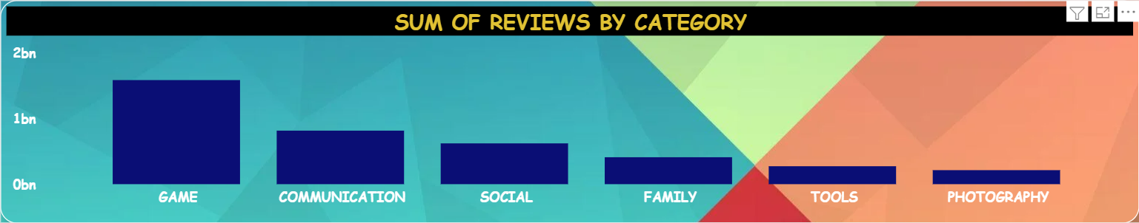

Game has highest review by category

REVIEW BY ITS TYPES

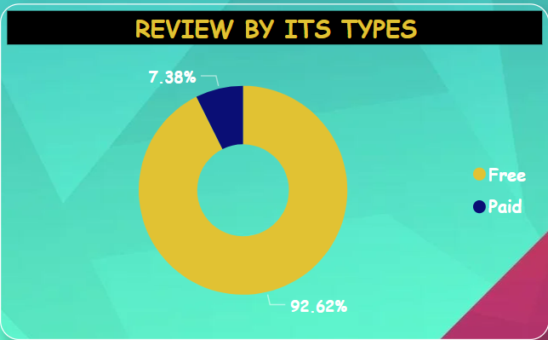

Free apps are reviewed more than paid apps

**Analysing Google Apps Store Wireframe Author: Seerat Fatema**

**REVIEW VS RATING BY GENRES**

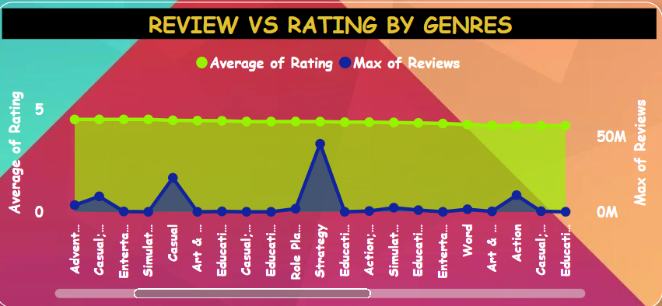

**Analysing Google Apps Store Wireframe Author: Seerat Fatema**

**Rating Analysis**

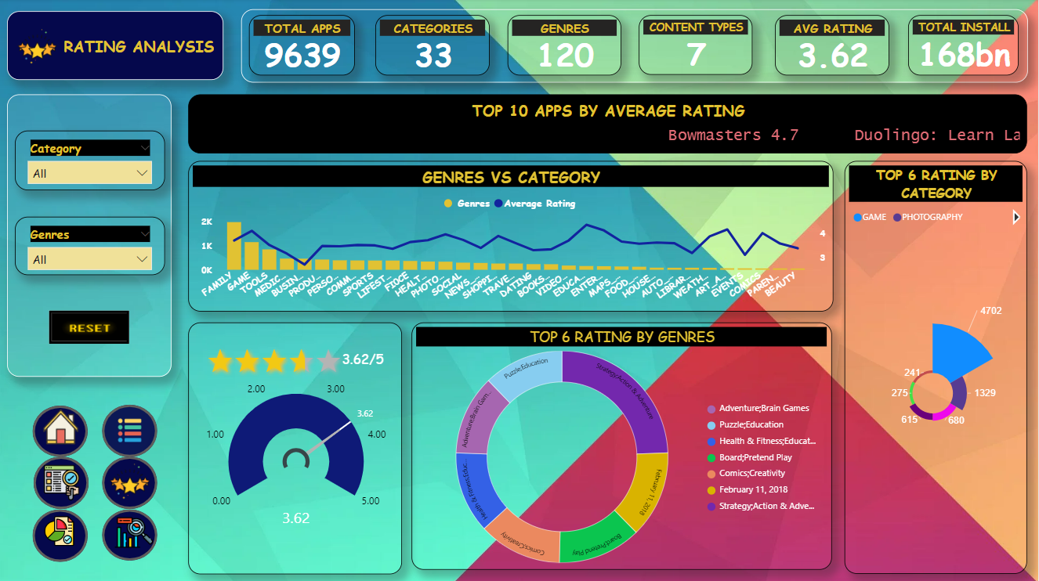

* **Slicers for Filtering**: Add slicers to allow users to filter the data. Include slicers based on relevant criteria, such as Category, Genres, Type . Users can interact with the slicers to dynamically update the graph based on their selections.
* **Line and stack column chart:** Represent Genres vs Category by their average rating
* **Sunburst Chart:** Represent Top 6 Genres by Rating.
* **Asterplot Chart:** Represent Top 6 Category by Rating.
* **Tachometer:** Measures rating out of 5.
* **Rating visuals:** Represents Rating in terms of stars.
* **Scroller**: Represents Top 10 Average Rated Apps
* **Navigation Buttons**: Add six buttons at the bottom left side of the home page out of which five are for easy navigation to other sections of the dashboard and one is for data analyzation of installation page.

Label the buttons and by clicking on each button will redirect users to the respective pages.

**Analysing Google Apps Store Wireframe Author: Seerat Fatema**

**Analysing Google Apps Store Wireframe Author: Seerat Fatema**

**TOP 10 APPS BY AVERAGE RATING**



Bowmasters has the highest average rating i.e 4.7

**GENRES VS CATEGORY**

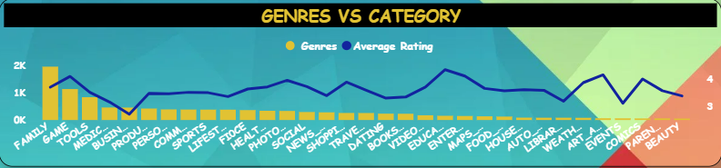

Family is the category which has the highest genres with average rating of 3.71

**TOP 6 RATING BY GENRES**

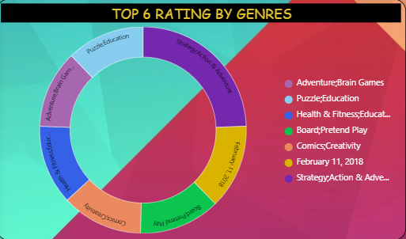

Strategy;Action & Adventure is the most rated genres.

**Analysing Google Apps Store Wireframe Author: Seerat Fatema**

**TOP 6 RATING BY CATEGORY**

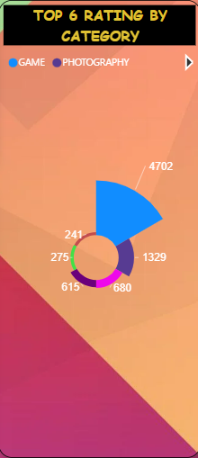

Game has the highest rating in Category

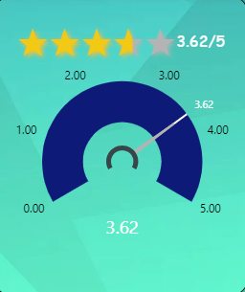

Overall, Average rating is 3.62.

**Analysing Google Apps Store Wireframe Author: Seerat Fatema**

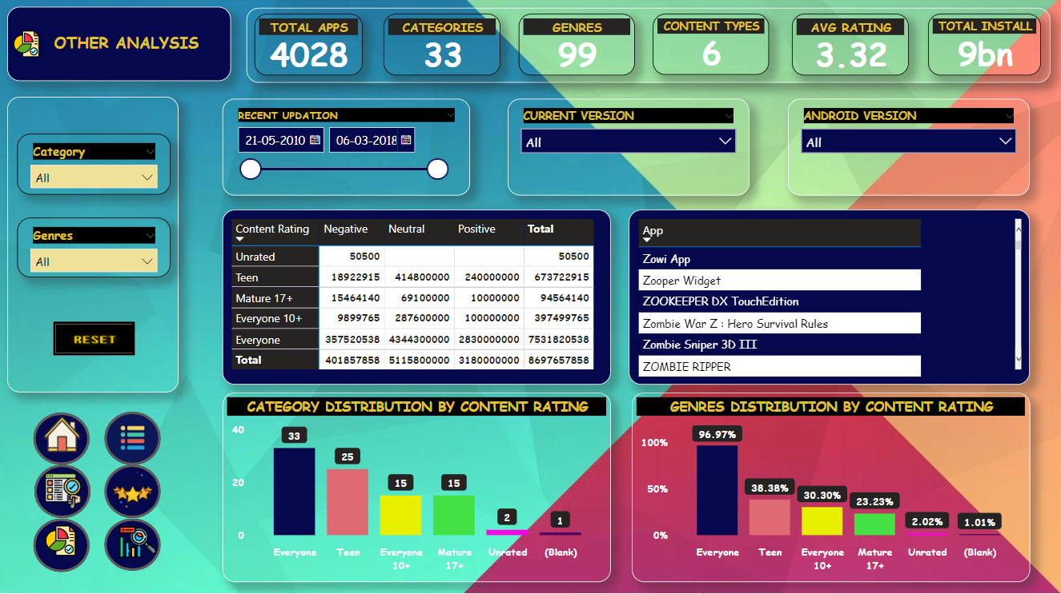

* **Slicers for Filtering**: Add slicers to allow users to filter the data. Include slicers based on relevant criteria, such as Category, Genres, Type . Users can interact with the slicers to dynamically update the graph based on their selections.
* **Matrix:** Represent Content Rating along with sentiments.
* **Table:** Represent name of Apps.
* **Clustered Column Chart:** Represent Category and Genres distribution by Rating
* **Navigation Buttons**: Add six buttons at the bottom left side of the home page out of which five are for easy navigation to other sections of the dashboard and one is for data analyzation of installation page.

Label the buttons and by clicking on each button will redirect users to the respective pages.

**Analysing Google Apps Store Wireframe Author: Seerat Fatema**

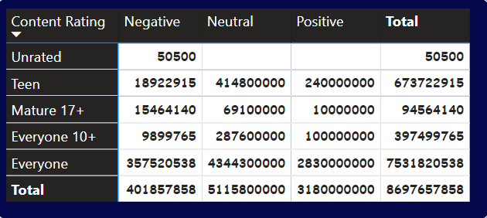

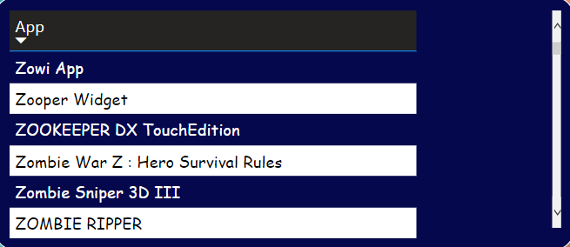

**Analysing Google Apps Store Wireframe Author: Seerat Fatema**

**CATEGORY DISTRIBUTION BY CONTENT RATING**

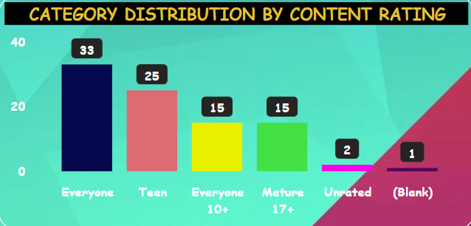

Content Rating Everyone has the highest number of Category

**GENRES DISTRIBUTION BY CONTENT RATING**

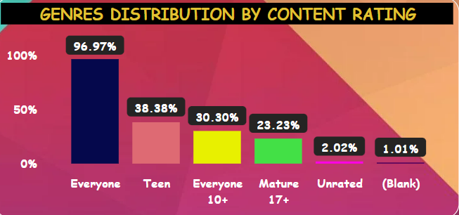

Content Rating Everyone has the highest percentage of Genres.

**Analysing Google Apps Store Wireframe Author: Seerat Fatema**

